Five Ways to Finish Your Dissertation

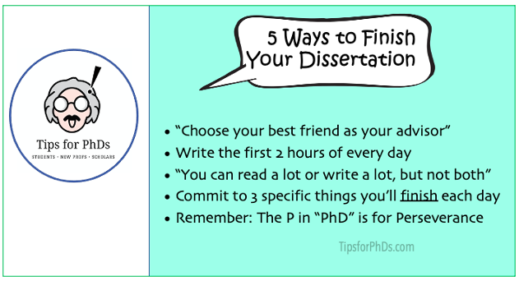

Most "How to finish your thesis" advice is somewhat obvious -- even if we don't follow it. Sometimes we don't follow it because it seems too difficult. Other times we don't follow it because it's so general, we don't know how to start.

Here's five pieces of useful dissertation advice I heard that were 1) nonobvious, 2) doable, and 3) specific.

1. “Choose your best friend as your advisor.” I heard this from a Med School professor friend who said, “And choose your older brother to be your second committee member and choose your favorite uncle to be your third member.” We tend to choose our dissertation committee based on who’s most famous. Consider which professors most want you to graduate. [Read more]
2. "Write the first two hours of every day." The guy who told me this, pretty much said it like a command: no email, no breakfast, no class stuff. Before breakfast and before the kids wake up. It sets a productivity vibe for the whole day. [Read more]

3. “You can either read a lot or you can write a lot, but you can't do both.” We can sometimes use reading as avoidance behavior for writing. There's diminishing returns to trying to read everything in a subject area.
4. Write down the 3 specific things you'll finish each day. Better to have three things completed than 20 things pushed ahead an inch. [Read more]
​
5. Remember: “The ‘P’ in PhD stands for Perseverance.” – The smartest and most talented people in PhD programs aren’t always the ones who graduate.

